**Demo 7**

**Create Descriptive Statistics**



**Steps to be followed:**

**Step 1: Open the Excel file**

* 1. Open the file named **Descriptive Statistics.xlsx**

**Step 2: Create Descriptive Statistics**

2.1 Click on the Data tab

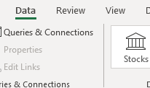

In the Analyze panel, click on Data Analysis

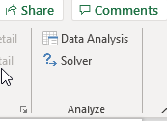

2.2 Click on Descriptive statistics and click OK

2.3 Choose the Input Range and Output Range. Click on Labels and Summary Statistics

2.4 The results will look like this

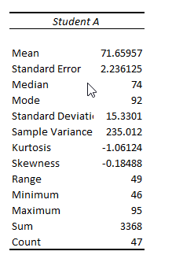

2.5 Repeat the same for Column C range

2.6 This is the final output

